

Invitation to Tender
Location: Mountwood Farm, Chenies WD3 6ES
Works: Hedge planting

Issued: 28th August 2025
Site Plan
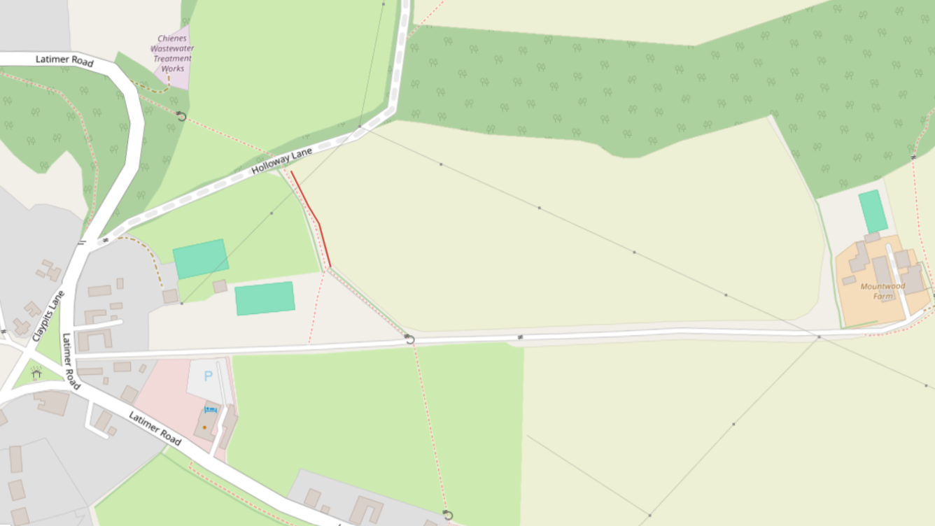
New hedge (120m)
Schedule of works
Hedge planting
Total length required = 120m

The hedge planting should be at a density of 6 plants per metre planted in a staggered double row 40cm apart, using 45-60 cm 2 year-old whips of local provenance. The centre of the new hedge should be no closer than 1.2m from any fence. All whips should be staked and protected with a spiral guard. Every 30m a whip should be put into a tree guard with a stake with a view to becoming a standard tree.

Up to 20% of failures should be replaced in the following planting season.

The possible mix of hedging whips is as follows, to be finalised at a later date:

Hawthorn - 45%
Field Maple - 15%
Hazel - 15%
Hornbeam - 5%
Wayfaring Tree - 10%
Buckthorn - 5%
Guelder Rose - 5%
Spindle - 5%
Wild Cherry - 5%

Objectives and restrictions
- Vehicle movements will be kept to a minimum. Access routes will be agreed with the project manager before work.
- All staff will be suitably qualified and experienced for the work undertaken and will wear appropriate personal protective equipment.
- Appropriate signs will be installed by the contractor to warn of work in progress.
- Work must be carried out in suitable weather conditions to minimise ground disturbance, and before the end of December 2024.

Proposal
Tenders for each task will be evaluated on the basis of the following details:
- An understanding of the project brief.
- A detailed breakdown of costs for delivering the project (including materials and daily rates/costing model and any other specific costs) according to the schedule of works.
- How the work will be a carried out (a range of options are encouraged to be included).
- Machinery that will be used to carry out the work.
- How ground conditions will be protected.
- An estimation of when the work will take place and how long it will take to complete.
- Arrangements for the length and nature of warranties on works.
- Details of your insurance.
- Organisational and individual skills, knowledge and experience.
Please provide full contact details of the lead contact.

Submission
For a site visit or questions please contact: Harriet Bennett, Landowner and Farming Engagement Adviser (Chilterns Conservation Board).
hbennett@chilterns.org.uk
07946 629708
Tenders should be submitted by 17:00 on 30th September 2025 to Harriet Bennett (details above).
References from previous clients may be requested during the assessment process.

