**Invitation to Tender**

*Location: Torrington Farm, Chesham HP5 3QJ*

*Works: Hedge planting*

***Issued: 28th August 2025***

**Site Plan**

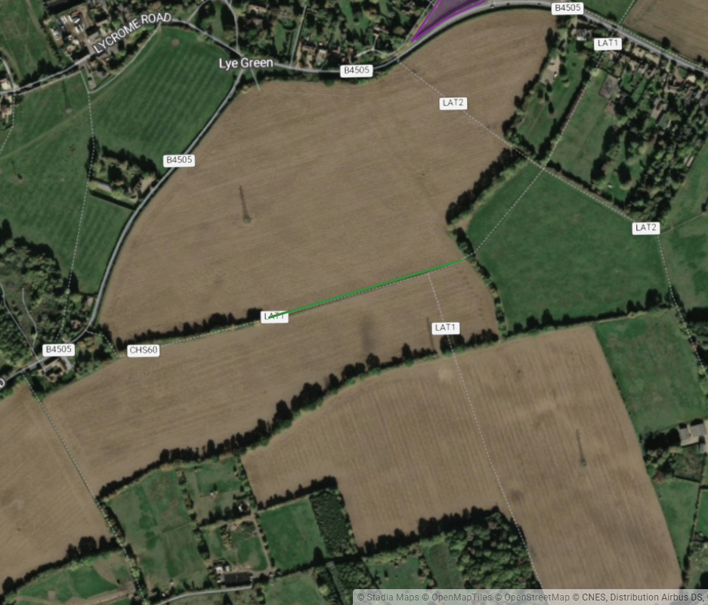

New hedge

**Schedule of work**

**Hedge planting**

Total length required = 323m

The hedge planting should be at a density of 6 plants per metre planted in a staggered double row 40cm apart, using 45-60 cm 2 year-old whips of local provenance. The centre of the new hedge should be no closer than 1.2m from any fence. All whips should be staked and protected with a spiral guard. Every 30m a whip should be put into a tree guard with a stake with a view to becoming a standard tree.

Up to 20% of failures should be replaced in the following planting season.

The possible mix of hedging whips is as follows, to be finalised at a later date:

Hawthorn - 45%

Field Maple - 15%

Hazel - 15%

Hornbeam - 5%

Wayfaring Tree - 10%

Buckthorn - 5%

Guelder Rose - 5%

Spindle - 5%

Wild Cherry - 5%

**Objectives and restrictions**

* Vehicle movements will be kept to a minimum. Access routes will be agreed with the project manager before work.
* All staff will be suitably qualified and experienced for the work undertaken and will wear appropriate personal protective equipment.
* Appropriate signs will be installed by the contractor to warn of work in progress.
* Work must be carried out in suitable weather conditions to minimise ground disturbance, and before the end of December 2024.

**Proposal**

Tenders for each task will be evaluated on the basis of the following details:

* An understanding of the project brief.
* A detailed breakdown of costs for delivering the project (including materials and daily rates/costing model and any other specific costs) according to the schedule of works.
* How the work will be a carried out (a range of options are encouraged to be included).
* Machinery that will be used to carry out the work.
* How ground conditions will be protected.
* An estimation of when the work will take place and how long it will take to complete.
* Arrangements for the length and nature of warranties on works.
* Details of your insurance.
* Organisational and individual skills, knowledge and experience.

Please provide full contact details of the lead contact.

**Submission**

For a site visit or questions please contact: ***Harriet Bennett,*** Landowner and Farming Engagement Adviser (Chilterns Conservation Board).

[hbennett@chilterns.org](mailto:hbennett@chilterns.org).uk

07946 629708

Tenders should be submitted by 17:00 on 30th September 2025 to Harriet Bennett (details above).

References from previous clients may be requested during the assessment process.