Brief: Architectural consultant/Quantity Surveyor

Not Bourne Yesterday: Chalk Stream Communities of the Chilterns

- Introduction

1.1 The Chilterns Conservation Board and Chilterns National Landscape
The Chilterns National Landscape is a designated Area of Outstanding Beauty and is nationally protected landscape comprising a ridge of chalk hills stretching from Goring on Thames in South Oxfordshire to Hitchin in Hertfordshire, covering an area of 833km2.
The Chilterns Conservation Board (CCB) is an independent statutory body established by Parliamentary Order in 2004. It has three statutory purposes:

- conserving and enhancing the natural beauty of the area of outstanding natural beauty
- increasing the understanding and enjoyment by the public of the special qualities of the area of outstanding natural beauty
- seeking to foster the economic and social well-being of local communities within the area of outstanding natural beauty

In fulfilling these purposes, the Board has a duty to seek to foster the economic and social wellbeing of local communities within the National Landscape without incurring significant expenditure. The 27 Board members all live in or close to the Chilterns and represent the interests of the local community.

The Board has a duty (under the Countryside and Rights of Way Act 2000) to produce a plan which outlines its policies for the management of the National Landscape. The Board’s role is to guide and contribute to the implementation of the plan, alongside all those whose activities influence the National Landscape.

  - Not Bourne Yesterday project summary

Chalk streams are a globally rare and precious habitat. They are England’s rainforests but are fragile and in rapid decline. Fostering a sense of connection and value in communities through which they flow will be key to ensuring their recovery and long-term survival. Millennia of human intervention and management has left a legacy of artificially disconnected river systems, bearing the still visible physical scars of long-gone industry and neglect.

Made possible by a £350,000 investment from the National Lottery Heritage Fund, Not Bourne Yesterday aims to reconnect communities with their local chalk streams, restoring both the rivers and landscapes they flow through. By nurturing a personal connection with these living waterways, Not Bourne Yesterday will build stronger relationships between people and their chalk streams, at a time when the rivers most need champions and people most need the wellbeing that being near water can bring. Together with partners and volunteers, the programme will tell story of these rivers with the everyday lives of the people – past, present and future – who live alongside them.
Not Bourne Yesterday is currently in an 18-month Development Phase until September 2026. If our second round bid is successful, the Delivery Phase of the programme will be delivered over five years, with an anticipated completion in 2031.
A map showing the Chilterns National Landscape and its chalk streams is included with this Brief (Figure 1).
To this end, one of the NBY projects, Testing the waters, involves the development of a Field Study Centre at Restore Hope Latimer, Buckinghamshire (Figure 2). This facility will be a space for schools and other groups to study water ecology. The location at Restore Hope in Latimer is on the middle Chess and offers the perfect opportunity for a dedicated building which will serve as a base for visiting groups.
This specification is part of our formal tendering process and CCB is seeking an individual or a company to undertake this work.

- Purpose and approach

We wish to have all design modifications and planning permissions secured in the Development phase (Dec 2024 – September 2026), so that works can commence in the Delivery Phase (2026 – 2031). A multipurpose facility, the Study Centre would also be used by the Chilterns Chalk Stream Project to train Citizen Scientists to monitor all the Chilterns rivers as well as local groups, university students and researchers who monitor the Chess. The structure would be maintained beyond the life of the project by the Restore Hope charity, who would also use the facility for outreach and engagement with a wide variety of audiences.
The CCB wishes to commission a consultant who can conduct a feasibility study for the site at Restore Hope, Latimer, to repurpose a building (which would need to be potentially dismantled, transported and erected at the site at Restore Hope).
We would like the feasibility study to provide a comprehensive analysis of the practicality and viability of the Testing the waters project at Restore Hope, Latimer.

We would want the final report to include:

- Site analysis, including an evaluation of the existing conditions of the construction site and any environmental constraints
- As this needs to be a repurposed building, we would like ideas on where or how we could locate this building. We would need the building to:
  - Hold at least 30 adults – potentially more if possible
  - Explore the option of toilets adjacent to the building and how this would work in terms of the waste water
  - We would like the building to be large enough for equipment such as benches, projector, projector screen etc. – see Figure 3
  - Have a storage area for equipment, wellington boots and coats
  - Hand washing facilities and a small kitchen area
  - To note, there is no building on site which can currently be repurposed
- Detailed breakdown of the cost of the project, including materials, labour and any permits and permissions (including planning permission, conservation area and registered parkland consents etc.)
- How the building could be made as environmentally friendly as possible – would there be options to add solar panels, a green roof, manage the thermal comfort of the building in the most eco-friendly way etc.
- Details on the structural integrity of the site and building, how the site will have utilities such as electricity, any building code compliances
- How the building itself and getting to the building will be accessible to those with mobility issues
- A review of any legal and regulatory compliance which might be needed
- Any potential risks and how they could be mitigated
- Timeline of the project – how long is it expected the project will take?

This feasibility study is expected to commence by 13th October 2025 and be completed by end of January 2026, with the final report being submitted this month.

Tenders must demonstrate value for money. The contract will be led by the CCB, and the point of contact with be the Not Bourne Yesterday Development Manager.

- Requirements of the successful Consultant

The successful Consultant will provide a technical report which outlines the following:

- Advice on where a repurposed building could be sourced
- Advice on the potential of the site and design, working out feasibility within the constraints of the Project budget.
- Presentation of detailed information on the projected cost of individual elements of work
- Organisation of the division of the project into component work packages (letting of any work contracts will be done in the Delivery Phase, subject to a successful Stage 2 NLHF bid)

- Research and make clear any contractual or legal matters that may need mitigation.
- Work closely with the Development Manager to identify the best options for realising the project vision
- Detailed drawings of how any potential repurposed buildings would work in the space
- Production of a final technical report, taking account of comments received to the draft version.

- Quotation and Proposal Information Required

Consultants must submit their proposals for meeting the above Specifications and Requirements. The proposal should include:

- A written methodology that explains how you would meet the Specifications and Requirements above.

The CCB would like to see:

- A proposal encompassing the criteria outlined above
- Viability. Please provide
- a detailed time plan to demonstrate how the idea will be complete;
- details of what considerations will be included

- Value for Money. Please indicate in your time plan who will be the key personnel working on this project, including the number of days each will commit to this project.

- Experience. Please provide examples of relevant past projects, and details of the experience (CV) of all personnel who would be involved in this appointment.

- Price, specifying whether this includes VAT

- Quotations must contain your company name and contact details

- Evaluation

Proposals from Consultants will be evaluated on the basis of:

- The quality and clarity of the proposal
- Viability of proposals
- Value for money
- Experience of Consultants

- How to apply

If you are interested in this contract, please send a proposal to fcrowther@chilterns.org.uk by 3rd October 2025. For an informal discussion, please contact fcrowther@chilterns.org.uk

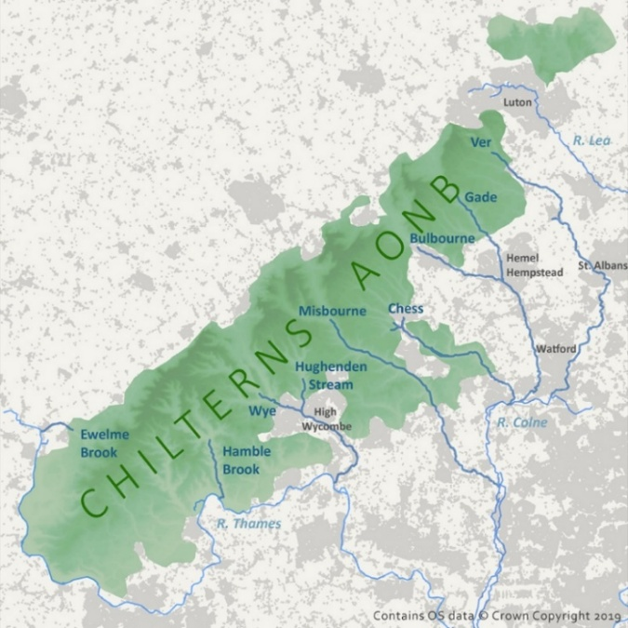

Figure 1: Chalk streams in the Chilterns National Landscape
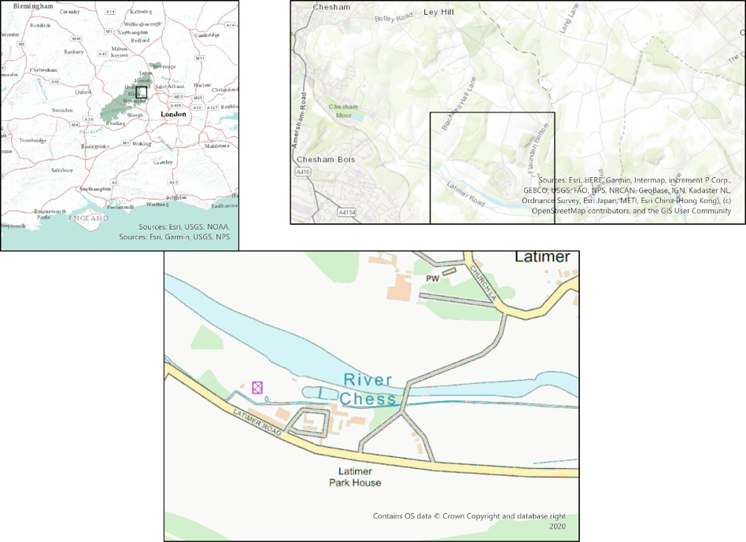

Figure 2 Location of Restore Hope at Latimer, within the Chilterns AONB. Purple square is site of structure

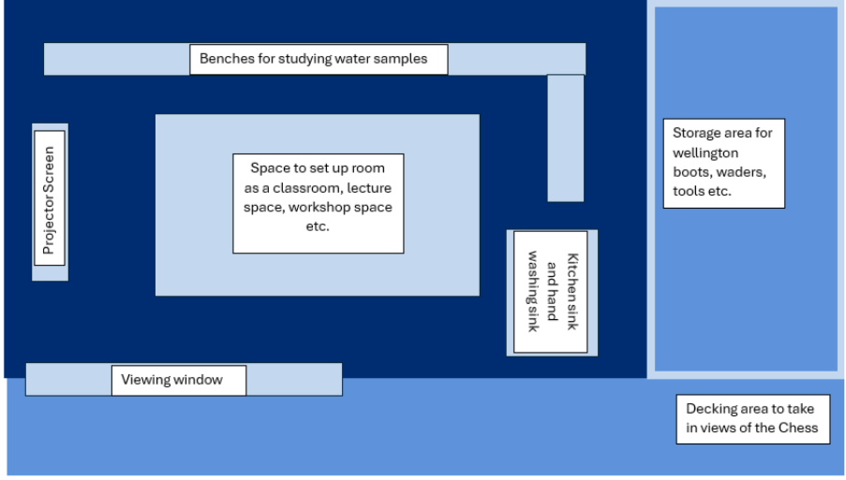
Figure 3: Idea of lay out of inside learning lab

