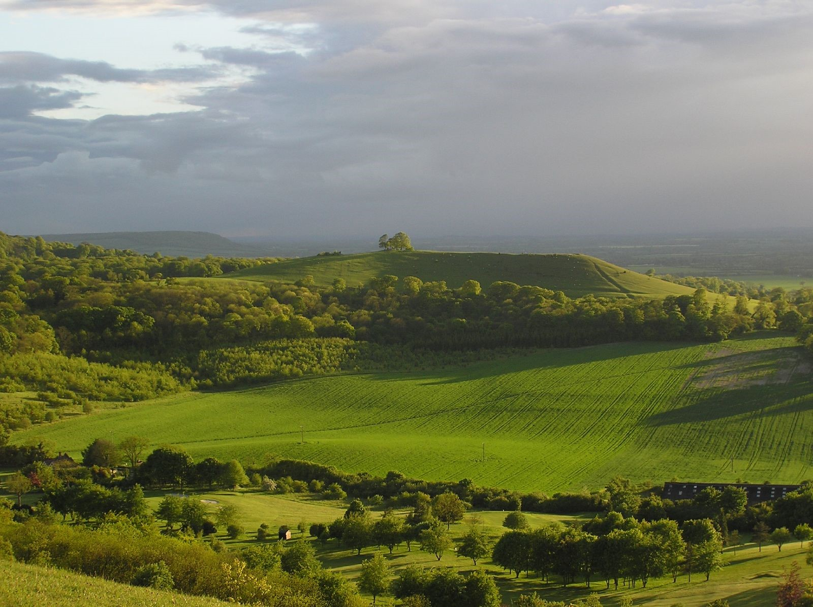
The Chilterns National Landscape – View from Coombe Hill Photo: Richard Gillin

Role Information

Role title: Head of Programmes

Location: Chilterns Conservation Board, The Lodge, 90 Station Road, Chinnor, Oxon, OX39 4HA

Salary: £55,000 per annum depending on experience

Benefits: Package includes Local Authority pension and access to healthcare scheme

Hours: Full time 37.5 hours per week

Contract type: Permanent

Reports to: Chief Executive

Responsible for: c.4 staff

About the Role

This is a new role which provides a rare and exciting opportunity to join a multi-disciplinary team working in one of the country’s most outstanding and most accessible protected landscapes.

The Chilterns Conservation Board (CCB) is a statutory body established by Parliamentary Order in 2004. It is one of only two Conservation Boards in the country set up under the Countryside and Rights of Way Act 2000. Our primary role is to promote the conservation and enhancement of the natural beauty of the Chilterns AONB, now known as the Chilterns National Landscape. Where compatible with this purpose, we also promote public understanding and enjoyment of its special qualities and seek to foster the economic and social well-being of local communities.

As a member of the Senior Leadership Team (SLT), you will work closely with the Chief Executive, the wider SLT and the Board to shape and deliver the organisation’s strategic priorities, objectives and performance outcomes, while playing a key role in driving organisational success, fostering collaboration across teams and exemplifying the leadership, professionalism and values expected of a senior leader.

We are looking for a strategic, credible and inspiring leader with excellent interpersonal skills and the ability to build trusted relationships across a wide range of stakeholders, including colleagues, partners, funders and government bodies. You will combine a collaborative and inclusive leadership style with the confidence to make decisions, provide clear direction and deliver results in a complex and evolving environment.

You will bring a strong track record of developing and delivering large conservation, heritage or other landscape-scale programmes, together with excellent communication skills, political awareness, sound judgement, resilience and meticulous attention to detail.

Role Purpose

This is a senior leadership role responsible for shaping, resourcing and delivering a high-quality portfolio of programmes and projects for the Chilterns National Landscape. The post-holder will ensure that programmes are strategically aligned to the AONB Management Plan for the Chilterns National Landscape and Organisational Strategy, and are delivered with strong governance, financial control, risk management, and measurable impact.

The role requires oversight of complex, multi-partner initiatives supported by a range of funders including Defra, the National Lottery Heritage Fund, the Environment Agency and water companies. The successful applicant will be expected to bring strong programme leadership, sound judgement and the ability to balance strategic oversight with day-to-day delivery.

Key priorities include embedding effective programme and project management approaches, strengthening a culture of risk management, health and safety, compliance, and ensuring that monitoring, evaluation and learning are consistently built into delivery. The post-holder will also play a leading role in identifying opportunities, developing proposals and securing resources to sustain and grow the Chilterns National Landscape’s programme of work.

Key Accountabilities

Programme and Project Oversight

- Programme / Project Management: Ensure programmes and projects are applying recognised programme and project management methodologies (eg MSP) and use project management software to maintain structured plans, schedules, and documentation.
- Planning: Ensure programmes and projects are effectively planned to deliver their outcomes and the Management Plan, Organisation Strategy and Annual Business Plan but that they remain on track to deliver their own defined outcomes as well.
- Budgeting / Financial Management: Ensure the development of programme and project budgets and embedding of robust financial controls including forecasting, claims, monitoring expenditure, and ensuring compliance with funder procedures.
- Governance & Delivery: Ensure programmes and projects are effectively governed and remain on track to deliver their own defined outcomes whilst as well as the Management Plan, Organisation Strategy and Annual Business Plan.
- Reporting: Ensure externally funded projects are meeting all contractual, financial and reporting requirements.
- Risk Management: Ensure that programmes and projects are effectively addressing risks and issues, maintaining proactive mitigation plans and escalating concerns appropriately.
- Health and Safety: Ensure Health & Safety is effectively addressed across all programme activities with robust risk assessments, safe working practices, contractor compliance as well as incident management being undertaken in line with organisational requirements.
Strategic Planning

- CCB Strategy Development & Planning: Contribute to the development of CCB strategy and planning as a member of the Senior Leadership Team and in representing the work of the Programmes Team.
- Strategy Alignment: Ensure the Management Plan and Organisation Strategy priorities are clearly reflected in team as well as programme and project plans.

Partnership & Collaboration
- Partnership Development: Foster excellent working relationships and build collaborative partnerships with external delivery partners, local authorities, statutory bodies as required, as well as with key internal stakeholders.
- Fundraising: Develop excellent relationships with funders and work with programme and project managers to secure funding as well as supporting the CEO with broader fundraising activities.
- Collaboration: Collaborate with other protected landscape teams to ensure knowledge sharing, best practice and consistency of approach.

Monitoring & Evaluation

- Monitoring & Evaluation Frameworks: Implement monitoring, evaluation, and learning frameworks to evidence programme and project outcomes and impact as well as informing continuous improvement.

Organisation Management & Support

- Team / Line Management: Effectively manage the Programme Team, ensuring its effectiveness and continued development as a high performing team, addressing areas such as capability and capacity as required.
- Culture: As a member of the Senior Leadership Team, provide leadership, direction, and support across the CCB staff team, promoting high performance and a culture of learning and collaboration.
- CEO and Board Support: Collaborate with, report and provide support to the CEO and Board as required

How to Apply

To apply for this role, please download the application form, together with the equal opportunities monitoring form. Completed forms should be emailed to: office@chilterns.org.uk

The closing date for applications is 9am on Monday 20th July.

Successful candidates are expected to be invited to interviews held in the week commencing Monday 3rd August.

Applicants must be willing to undergo screening appropriate to the post, including checks with past employers.

For further information or informal discussion please contact: Dr Elaine King, Chief Executive (elaineking@chilterns.org.uk)

This job description does not constitute the terms and conditions of employment. It is provided only as a guide to assist the employee in the performance of their job. The job description is not intended to be an inflexible or finite list of tasks and may be varied from time to time following discussion with the post holder.

Person Specification

Qualifications
Essential:
- Undergraduate degree or equivalent qualification in a relevant field such as environmental management, ecology, conservation, geography, business or management
- Programme Management practitioner qualification (e.g. MSP or APM) or equivalent experience

Desirable:
- Project Management / Process Improvement qualifications (e.g. Prince 2, Agile, Six Sigma)
- Chartered Institute of Ecology & Environmental Management (CIEEM) or Chartered Institution of Water and Environmental Management (CIWEM) membership
- Risk management certification
- Outdoors First Aid (level 2/3)
- Institute of Sustainability and Environmental Professionals (ISEP) Practitioner or Full membership
Experience and Knowledge
Essential:
- Extensive programme management experience in a senior leadership role including planning, budgeting, governance, risk management, and quality assurance.
- Extensive knowledge of Programme and Project Management methodologies such as MSP, APM or Prince 2, Agile and Six Sigma)
- Knowledge of landscape scale nature recovery, conservation approaches, heritage enhancement, and environmental policy frameworks.
- Strong track-record of developing and delivering large conservation, heritage, or landscape character programmes, ideally within protected landscapes or in comparable environmental contexts.
- Track record of securing external funding for large scale programmes
- Proven ability to lead and manage high-performing multidisciplinary programme teams, including providing constructive feedback, supporting performance management, and encouraging training and professional development opportunities.
- Ability to manage complex programmes involving a range of players including contractors, consultants, and volunteers.
- Clear attention to detail when maintaining / reviewing programme documentation, including plans, schedules, risk registers, budgets, and funder reporting.
- Substantial knowledge of risk management principles, including risk assessments, mitigation planning, escalation routes, and programme level risk control.
- Strong understanding of health & safety legislation and best practice relating to outdoor conservation work, contractor oversight, volunteer management, and public engagement activities.

Desirable:
- Understanding of the Chilterns National Landscape’s purposes, statutory duties, management plan requirements, and partnership structures.

Skills and Abilities
Essential:
- Excellent analytical skills, with the ability to interpret complex information, assess risks, and inform decision-making.
- A strategic thinker with the ability to see the bigger picture and who can connect individual projects to organisational objectives.
- Strong communication skills, including the ability to write clear reports, present to stakeholders, and engage a wide range of audiences.
- Ability to build and maintain trusted relationships with partners, funders, communities, and internal teams.
- Strong organisational and time-management skills, with the ability to manage multiple projects and priorities simultaneously.
- Ability to promote safe working practices and embed health & safety compliance across programme activities.
- Confident in using digital tools, project management systems, and data to monitor progress and demonstrate outcomes.
Personal Qualities

Essential:
- A credible and dependable senior leader who demonstrates integrity, inspires confidence and can represent the organisation with professionalism.
- Strategic in outlook, with the judgement to balance long-term priorities with operational demands and make sound, well-evidenced decisions.
- Collaborative, inclusive and emotionally intelligent, with a natural ability to build trust and work constructively with colleagues, partners, funders and stakeholders.
- Resilient and calm under pressure, able to maintain momentum, adapt to changing circumstances and respond positively to challenge.
- Highly organised and conscientious, with a disciplined approach to follow-through, quality and attention to detail.
- Diplomatic and self-aware, with the confidence to lead, the tact to handle sensitive issues well, and the openness to listen and respond to different perspectives.
- Committed to fostering a positive, respectful and high-performing culture, with a genuine commitment to equity, diversity and inclusion.

